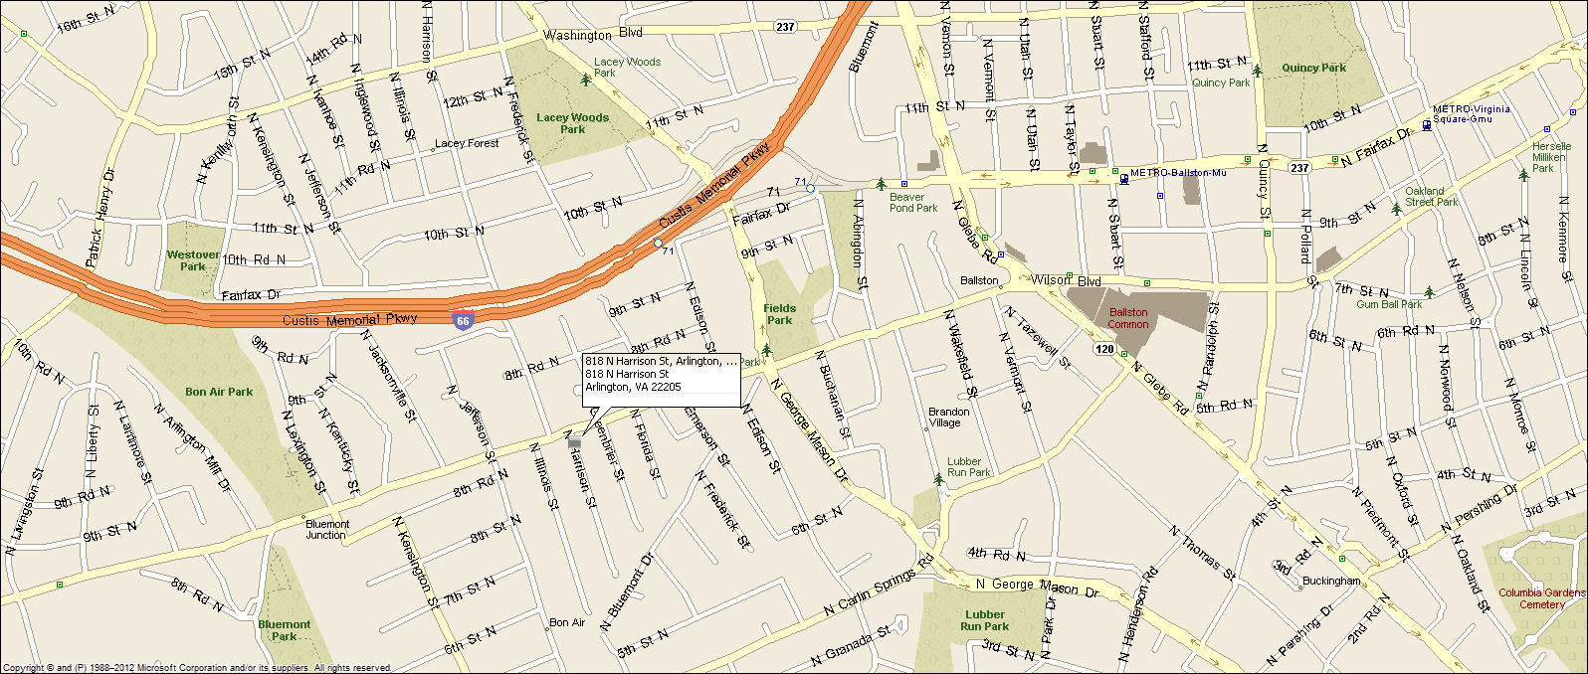
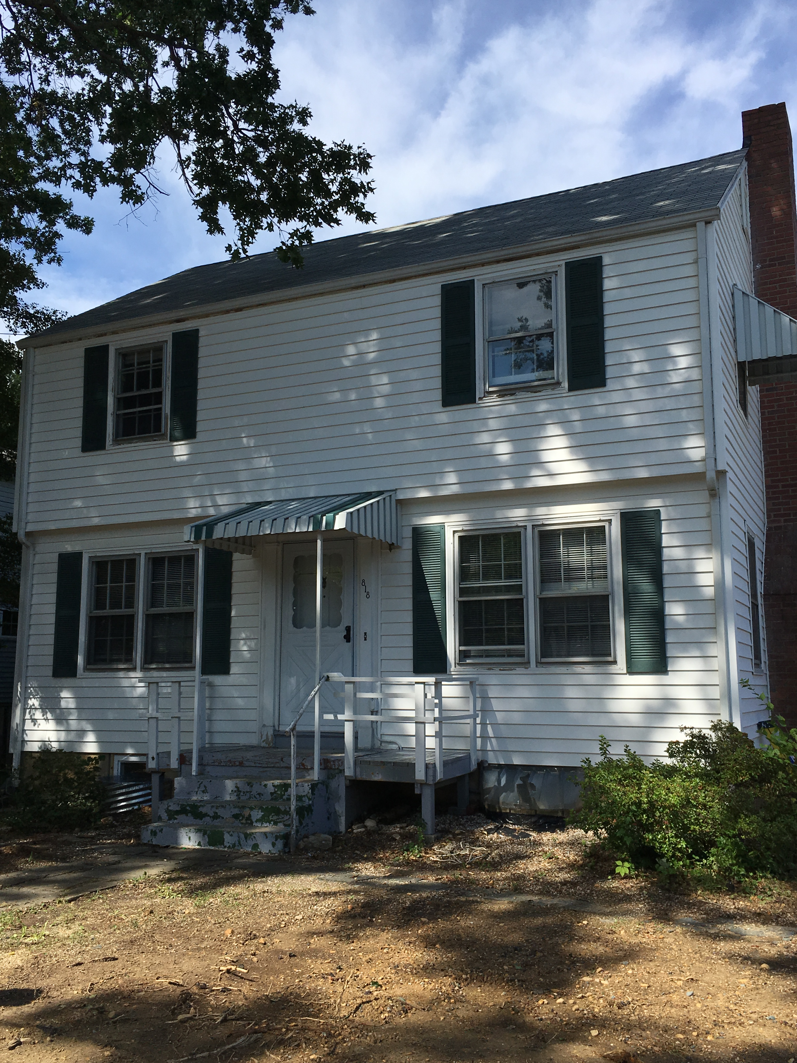
818 N. Harrison Street
Arlington, VA 22205
Extensively Renovated Colonial Home
Great location: Walk to Ballston Metro, Close to DC (5 mins)& major commuting routes.
- Four bedrooms, three full baths, one ½ bath. Two master suites.
- Central a/c, natural gas heat & hot water, new washer dryer.
- New kitchen w/ SS appliances & granite.
- Off street parking for 3 cars & 1 car detached garage
- Original refinished hardwood floors thru out.
- Private rear yard, fully fenced in, new rear patio.
- Established, quiet, sought after neighborhood.
- Lease terms: 1 year minimum, no smoking, no use of fire place, no pets.
RENT: $3,600.00 / month + utilities, contact Lyndsay Saffer 703-906-3082
Email: safferlyndsay@gmail.com

